Measure [A] of reactant A vs. time in fixed volume batch reactor at constant temperature

Data --> reaction rate model

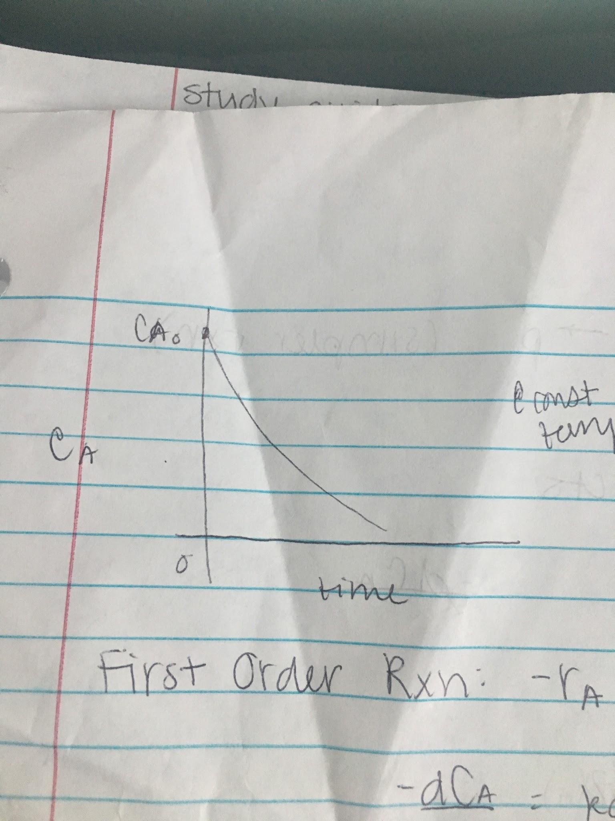

**First Order Reaction**

-rA = kCA1 = -dCA/dt

-dCA/CA = kdt

ln(CA/CA0) = -kt (hypothesis)

Compare data to hypothesis (statistical analysis)

1. Rate expression
2. Integrate
3. Compare: does it fit?

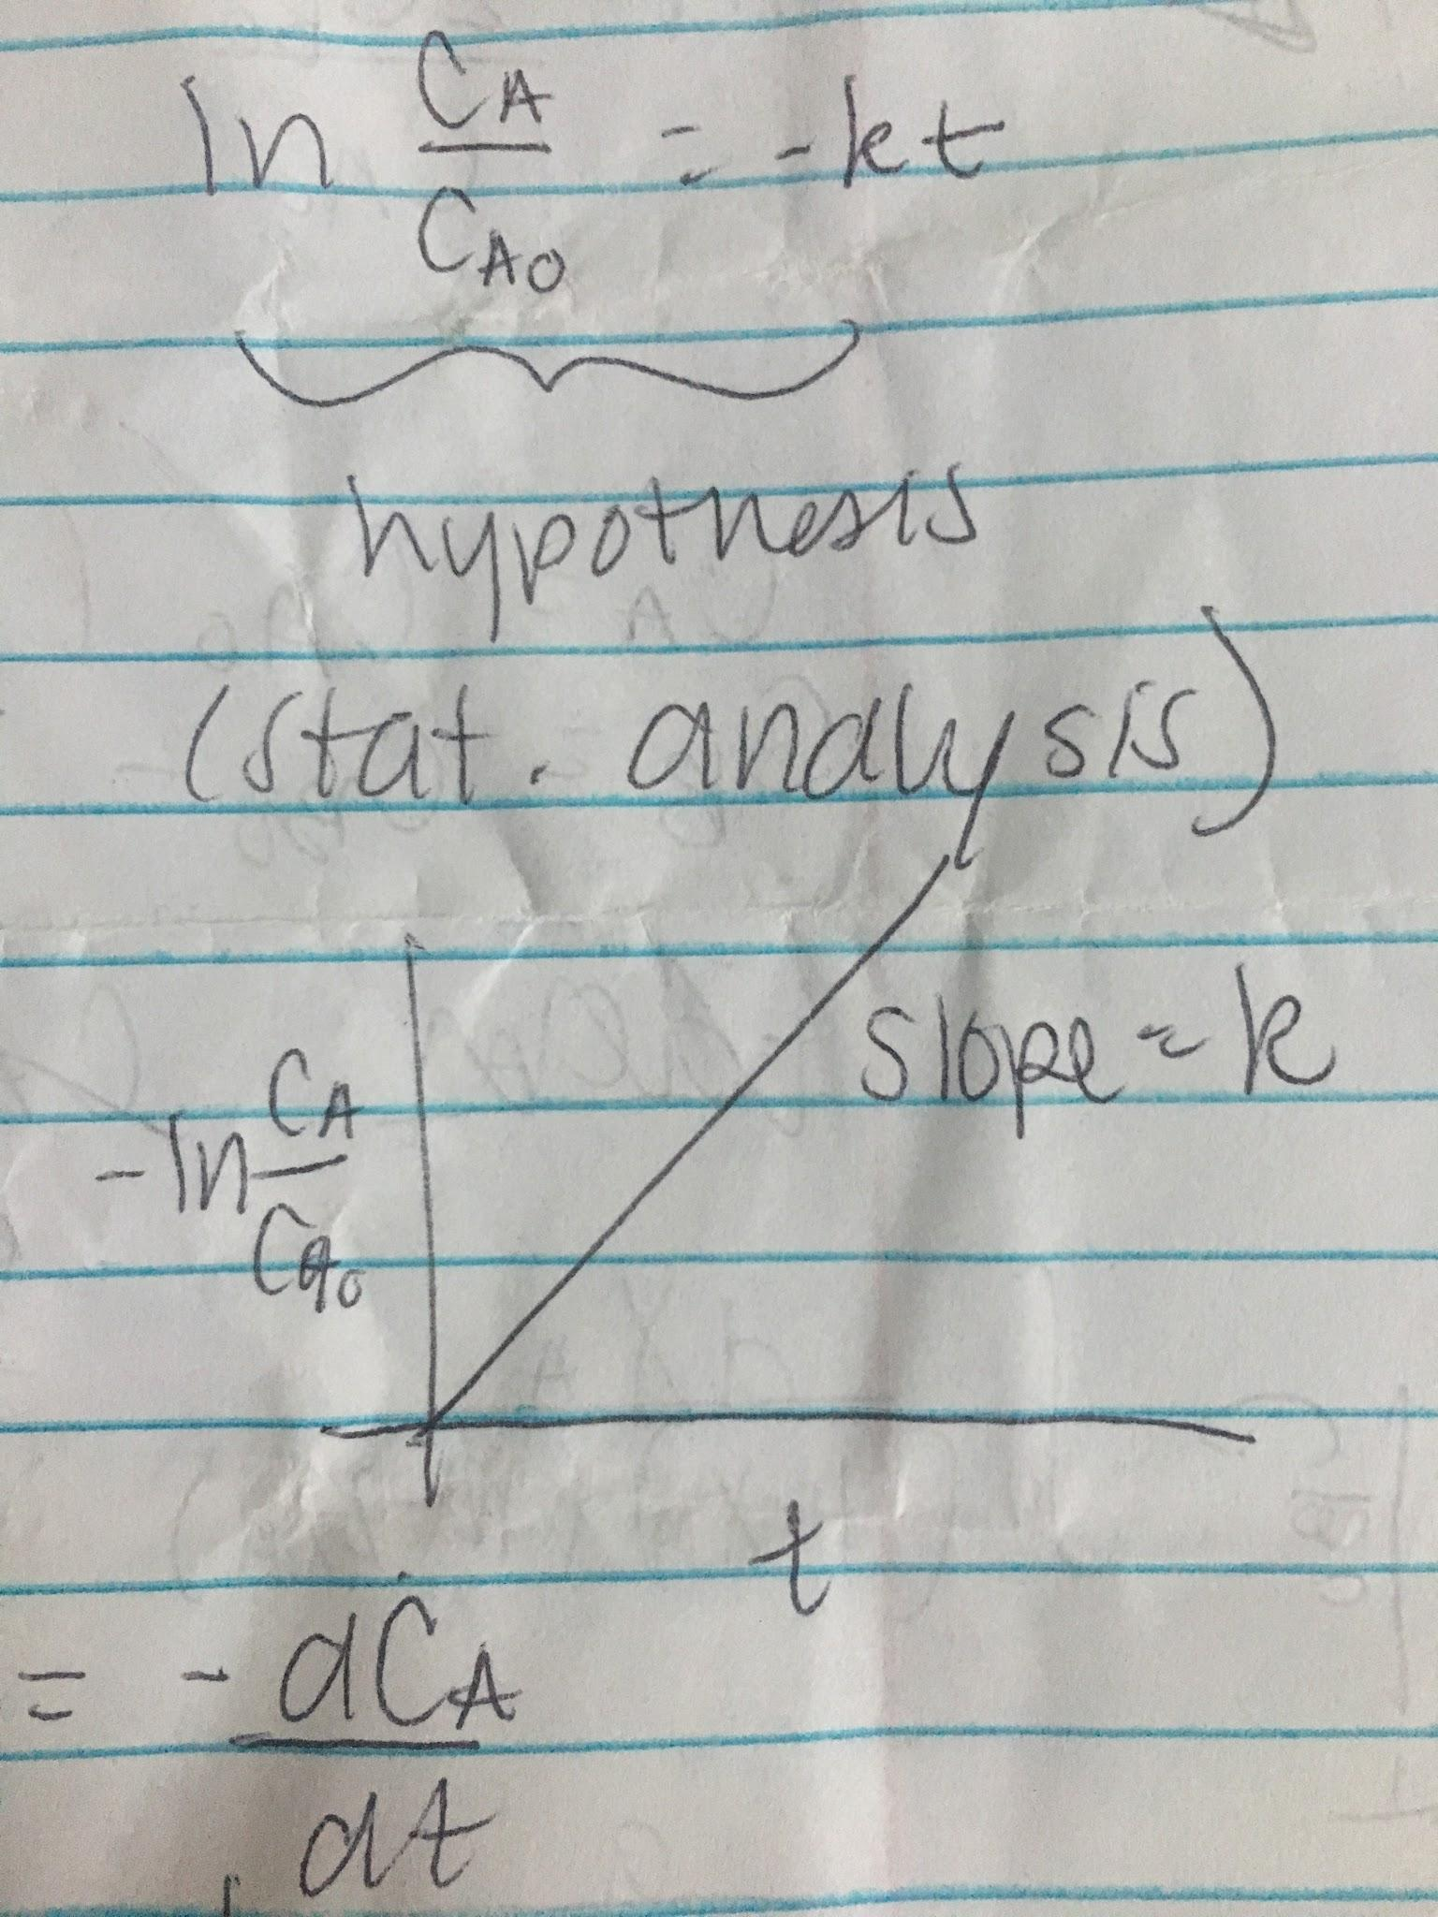

**0th Order Reaction**

A --> products

-rA = kCA0 = -dCA/dt

K = dCA/dt

-kdt = dCA

-kt = CA - CA0

Kt = CA0XA

**Second Order Reaction**

-rA = kCA2 = dCA/dt

-dCA/CA2 = kdt

1/CA - 1/CA0 = kt

CB0 = CA0 >>> 2A --> products (simpler reactions)

**A + 2B --> products**

-dCA/dt = kCACB

M = 2CB0/CA0

dXA/(1-XA)(M-2XA) (assume M ≠ 2)

CA = CA0(1-XA)

CB = CB0 - 2CA0XA

CA0dXA/dt = kCA02(1-XA)(M-2XA)

∫ dXA/(1-XA)(M-2XA) = ∫ kCA0dt

a/(1-XA) + b/(M-2XA) = 1/(1-XA)(M-2XA)

a(M-2XA) + b(1-XA) = 1

XA = 1

a(M-2) = 1

a = 1/(M-2)

XA = 0

aM + b = 1

B = -2/(M-2)

dXA/(1-XA)(M-2) - 2dXA/(M-2)(M-2XA) = kCA0dt

∫0XA dXA/(1-XA) - ∫0XA 2dXA/(M-2XA) = ∫0t kCA0(M-2)dt

CBCA0/CB0CA = ln[(M-2XA)/M(1-XA)] = CA0(M-2)kt M ≠ 2

**A + B + D --> products**

-rA = -dCA/dt = kCACBCD

CA = CA0 (1-XA)

CB0 = CB0 - CA0XA

CD0 = CD0 - CA0XA

In terms of XA

CA0 dXA/dt = kCA03(1-XA)(CB0/CA0 - XA)(CD0/CA0 - XA)

If CD0 --> ∞, reaction is reduced to second order reaction